Friends, Angels, and Patrons Benefits 2018

The Oxford Chamber Music Foundation (OCMF) is delighted that you are considering membership of the Oxford Chamber Music Festival by becoming a Friend, Angel or Patron. OCMF can only exist with funding from a variety of sources but is primarily supported by the generosity of our members.

Annual Membership Options:

Friend - £45 (single) £65 (double)
Benefits: Advance notice of forthcoming Festival concerts and activities | Priority booking |
E-mail newsletters throughout the year | Invitation to Members’ events | Name in the Festival programme | Opportunity to buy 1 Rover Ticket (single) and 2 Rover tickets (double) allowing access to all Festival concerts.

Angel - £100
Benefits as Friends plus:
Opportunity to buy 3 Rover tickets allowing access to all Festival concerts.

Patron – from £500
Benefits as Friends plus:
Your name listed as a Patron in advance publicity, as well as in the Festival programme.
Opportunity to buy 4 Festival Rover Tickets allowing access to all Festival concerts.

Please note: Fees and prices will be reviewed for the 2019 Festival.

OCMF Membership Form for the 2018 Festival

CONTACT INFORMATION. PLEASE COMPLETE YOUR DETAILS:

TITLE |  | FIRST NAME
SURNAME

ADDRESS

POSTCODE

EMAIL

TELEPHONE

LEVEL OF MEMBERSHIP

Friend (Single) ☐ Friend (Double) ☐ Angel ☐ Patron ☐

YOUR NAME IN THE FESTIVAL PROGRAMME
Please write how you would like your name to appear

Or, I wish to remain anonymous ☐
_____________________________________________________________________________

GIFT AID OCMF is a registered charity no: 1080114

I would like OCMF to reclaim tax on this donation. I am a UK taxpayer and pay an amount of income and/or capital gains tax at least equal to the tax to be reclaimed. ☐

No, I am not a UK taxpayer ☐

OCMF NEWSLETTER
By registering with your email address, you agree to receive email updates and other marketing literature including newsletters about OCMF and the Festival. Your information will not be shared with any third parties.

Signature and date:

_____________________________________________________________________________

PAYMENT OPTIONS (please tick box)

Single payments by cheque should be made payable to ‘OCMF’ and sent to ☐
Robert Warner, Treasurer OCMF, Perrotts Hill Farm, North Leigh, Witney, OX29 6PT.

Single payments by Bank Transfer should be made to OCMF, ☐
Account number: 02074862
Sort Code: 309635. Please reference ‘Member’.

Annual or monthly payments by Standing Order should be made by completing ☐ the Standing Order Form overleaf.

PLEASE NOTE THAT THE STANDING ORDER FORM OVERLEAF SHOULD BE SENT TO YOUR BANK WITH A COPY TO OCMF TREASURER, ROBERT WARNER.

To pay by Standing Order, please complete the details below and SEND THE COMPLETED FORM TO YOUR BANK OR BUILDING SOCIETY AND SEND A COPY TO
Robert Warner, Treasurer OCMF, Perrotts Hill Farm, North Leigh, Witney, OX29 6PT.

STANDING ORDER FORM

Your Bank/Building Society/Branch Name:

Your Bank/Building Society Address:

Your Sort Code: | Your Account Number:
Amount of Annual or Monthly Payment (please indicate):

Amount: £ Frequency: Annual / Monthly (delete as appropriate)

Payment date (Annual):

Payment date (Monthly):

Payment to be made to ‘OCMF’: Account number: 02074862 Sort Code: 309635
Lloyds Bank plc, Carfax, 1-5 High Street, Oxford, OX1 4AA

OXFORD CHAMBER MUSIC FESTIVAL

MEMBERSHIP FORM FOR THE
2018 FESTIVAL

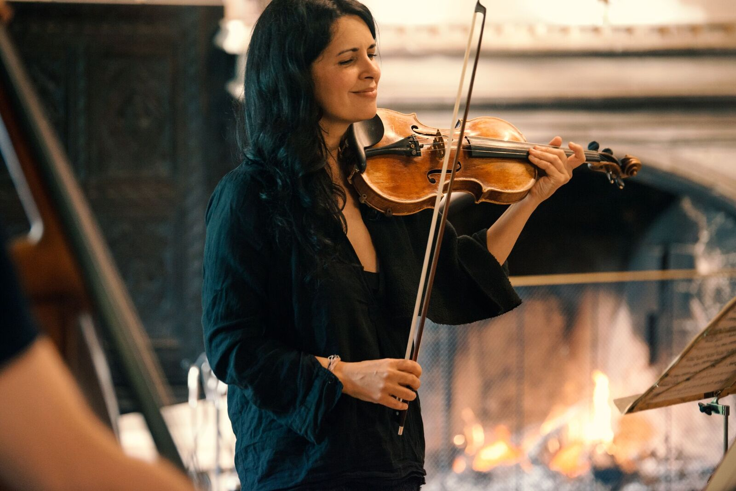
PHOTO: ARTISTIC DIRECTOR, PRIYA MITCHELL BY BALÁZS BÖRÖCZ

JOIN US!

The Oxford Chamber Music Festival is owned and organised by the
Oxford Chamber Music Foundation Limited (“OCMF”) a registered charity no.1080114.

